AGENDA ITEM NO. 9

CABINET
25 MARCH 2014

COLLABORATION FRAMEWORK

Report Submitted by: Lyndon Puddy, Interim Head of PSSU
Report Written by: Mark Sharwood, Public Service Development Manager

1. | Area Affected
1.1 | Not applicable.
2. | Purpose of Report
2.1 | To seek approval to put in place a collaboration framework which will be used to help ensure that there is a clear rationale for entering into collaboration with other organisations and to monitor that the expected benefits are being achieved.
3. | Key Messages
3.1 | - Presently there is not a consistent approach to ensuring the anticipated costs, benefits and accountability arrangements are part of a formal decision making process when deciding on whether to enter into a collaborative arrangement.  - No formal system for corporate monitoring of the compliance, performance and/or expected outcomes of significant collaborative projects or services is in place.  - A Wales Audit Office report highlights these gaps for both small and large scale collaborations and proposes that a system is put in place.
4. | Background
4.1 | There have been a number of drivers associated with the need to develop a collaboration framework. These include:  - Welsh Government policy on collaboration. The ideological stance from Welsh Government as highlighted in the Programme for Government is to encourage effective public service collaboration. The Williams Review on public services is likely to influence future policy concerning collaboration. Our own written submission to the Williams Review states that it believes that enhanced collaboration is a potentially more effective route to take for public services than local government re-organisation. In addition, Welsh Government continues to develop its approach to collaboration and intends to introduce a Local Government (Collaborative Measures) Bill in the life of the current administration.  - Reductions in funding which are impacting directly on local services and people and local authorities are under increasing pressure to reduce costs. Therefore the promise of reduced costs often associated with collaborative ventures is attractive to public services.  - The effectiveness of the governance arrangements in setting up collaborative ventures has been questioned by Wales Audit Office. In particular there is need to focus on assessing whether our approach to deciding the feasibility of collaborating is robust, and that the anticipated benefits from collaboration are being realised, and the improvement in the range and quality of services is maintained and enhanced. Their report submitted in January 2014 states “… we found scope to improve the planning and management of projects and the lack of information on costs and benefits makes it difficult to assess value for money.”  - The result of scrutiny into collaborative arrangements led to the Resources Overview & Scrutiny Committee fully supporting the Council being involved in collaborative arrangements. However, they recommended that a clear set of criteria and guidance should be established and implemented. Once in place, all collaborations should be evaluated / reviewed on a regular basis using the same criteria to ensure the desired benefit is set out at the start of the collaborative arrangements and these are being fulfilled.  - High corporate risk has been identified concerning a failure to develop strategies to deliver new shared or collaborative services which would result in:  - core service delivery standards not being met;  - cost the council money  - failing to adhere to all legislative/ governance requirements  - lose out on the potential benefits of collaboration i.e. reduced cost or increased expertise; and  - have an adverse effect on the Council’s reputation.
5. | Issues and Findings
5.1  5.2  5.3  5.4  5.5  5.6 | The objective of a corporate collaboration framework  Taking the drivers mentioned above into consideration, the objective of corporate collaboration framework is to:  - Establish a process for deciding if we as a Council should enter into a significant collaborative service.  - Establish a set of criteria for putting forward a clear rationale for the need to investigate the potential for entering into collaboration.  - Identify the costs and benefits expected from entering into collaborative arrangements and effective monitoring to see if they are being achieved.  - Clarify the governance arrangements of a collaboration including decision making, resource allocation, monitoring of progress and potential discussions on an exit strategy.  In drawing up the framework, the following principles have been employed to guide the thinking:  - Large scale collaborative projects or services should be monitored corporately because they have a significant impact on corporate finance, accountability, performance, citizens/service users and reputation. Smaller scale collaborations should be monitored by the relevant service.  - There should be a clear understanding of the reasons for entering into collaboration and understanding of the subsequent benefits accruing as a result of the collaboration.  - The framework should be flexible enough to reflect the potentially large variation in the types of services/projects that could be collaboratively provided.  - It should be easy to administer but have the vigour required to ensure clear accountability and decision making arrangements are in place.  The corporate collaboration framework suggested below hopefully fulfils the objectives above.  Definition of collaboration  There are different views on what can be considered collaboration. The Wales Audit Office used the following definition: “Seeking to maximise efficiency gains through the scale in economies of more effective co-operation and coordination between agencies across the whole of the public sector, not excluding the independent, voluntary and private sectors. By using co-ordination rather than competition, users and producers of public services are enabled to be on the same side. As a consequence, the best outcomes are obtained when those who use and those who provide services work together in collaboration.”  In the context of this framework, collaboration is concerned with the direct delivery or procurement of a service or programme of action / project across either local authority boundaries and/or more than one organisation e.g. Gwent Police or Aneurin Bevan University Health Board.  Examples of types of collaboration that would fall into this definition include:  - Co-location of services - joint use of assets but separate service provision, e.g. social work office located within health centre.  - Joint provision of services - services are provided jointly by two or more organisations or through a separate new organisation, e.g. the South East Wales Adoption Service (Torfaen, Monmouthshire and Blaenau Gwent).  - Provision of specialist services - specialist services are provided either more effectively in a larger geographic area (e.g. GWICES for independent living equipment) or scarce skills and resources are used to cover services across a wider area (e.g. Gwent wide combined Trading Standards)  - Provision of emergency or out-of-hours cover - services at specific times are provided across a wider area to make better use of a scarce resource, e.g. out-of-hours homelessness cover, social work cover and emergency crisis helplines.  - Cross public sector provision - services are provided to partnerships or other public sector organisations within spare capacity of the lead organisation, e.g. councils cleaning police offices, provision of financial and treasury services to police and fire services).  - Process simplification or standardisation - organisations working together to streamline or simplify processes, e.g. cross-Ayrshire process for fast tracking Building Warrants.  - Training - training could fit into some of the other categories, however, there are a number of different potentially significant shared training examples in public services that suggests it may be a category in its own right. E.g. specialist training in areas such as trading standards or child protection which may lead to a range of benefits to the collaborating partners.
5.7 Corporate Collaboration Framework Diagram
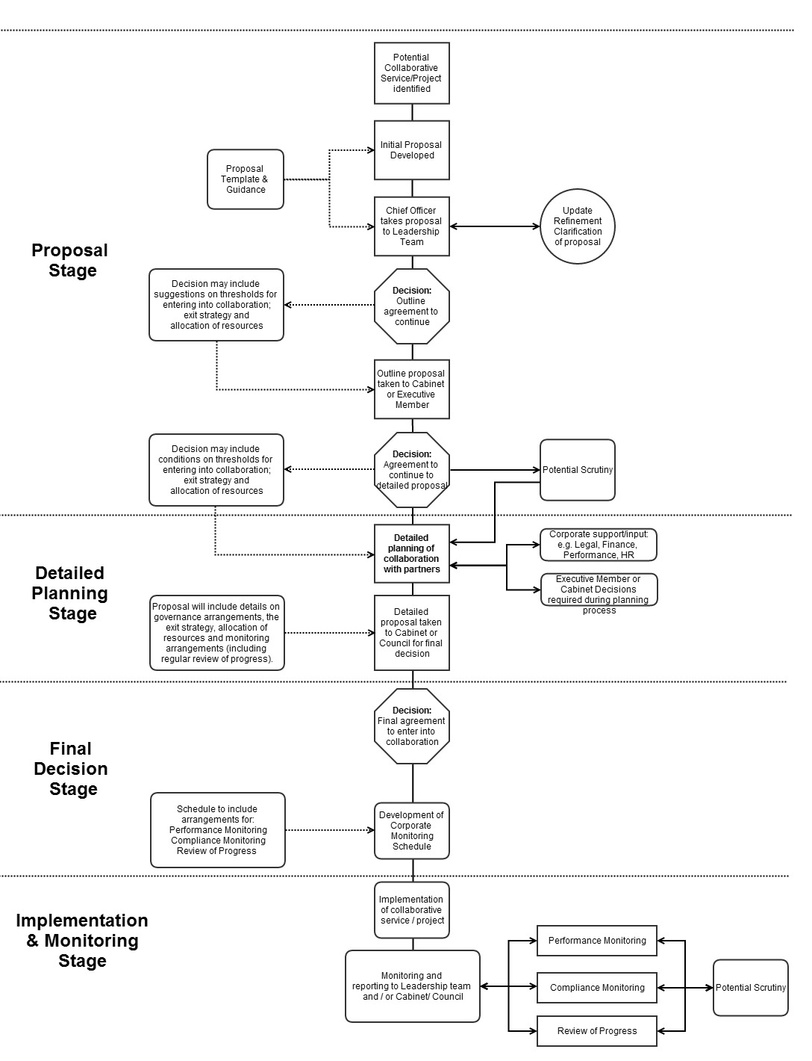

5.8  5.9  5.10  5.11  5.12  5.13  5.14  5.15  5.16  5.17  5.18  5.19  5.20  5.21  5.22  5.23  5.24  5.25  5.26  5.27 | Rationale and information required before entering into collaborative arrangements  To be able to make a decision on the acceptability of entering into collaboration, there should be a clear rationale. One or more of the following criteria (which are not mutually exclusive) could be used to help identify the rationale to both the leadership team and the political decision makers:  - Improved resource efficiency/utility (cost, staff and/or assets).  - Increased function or service efficiency/performance.  - Change in demand for service.  - Improved citizen / service user outcome (including consideration of client vulnerability).  - Government imperative - UK or Welsh Government policy, law, condition of funding etc. may require entering into collaborative arrangements.  - Risk Reduction - there is a risk (or risks) that might be mitigated or managed by entering into a collaborative endeavour e.g. financial pressure, change in legislation, technological, work force.  This framework introduces an element of corporate process and monitoring and to keep this to a reasonable level, it is suggested that the scale of cost and impact of the collaboration be the deciding factor on whether it should be part of a corporate monitoring process. Bearing in mind the range of criteria suggested above, it might be difficult to predetermine exact thresholds for making the decision.  It is therefore suggested that Leadership Team should make the initial decision on whether the collaboration should be considered part of the corporate monitoring process collaboration framework. This would require a discussion by Leadership Team based on initial details of:  - the rationale (please see the criteria suggested above)  - potential costs  - potential benefits (including a description of unquantifiable benefits)  - analysis of the possible alternative models of delivery  - initial thoughts on the basis for resource allocation  - initial thoughts on exit strategy thresholds  Having said that it might be difficult to set exact thresholds on what would be considered appropriate to trigger the need for corporate support and monitoring, there needs to be some idea of what would seem appropriate for taking the initial proposal to leadership team for discussion. It is recommended that the one or more of the following which give an idea of the scale or significance should be part of the collaboration framework :  - A statutory service or activity.  - A whole (or significant proportion) of a current service.  - The collaboration is likely to require an annual budget >£500,000.  - The collaboration would affect more than 20 employees.  - The collaboration would make a significant contribution to a corporate performance indicator/measure.  For collaborative activity that is not considered significant and requiring corporate monitoring, (i.e. that do not meet the thresholds outlined in 5.11) the final decision maker may be the the Executive Member as under the Scheme of delegation approved by Council in 2009 the decision ’to arrange for delivery of services with other public bodies or through joint arrangements’ is deemed a Category A Executive member Decision, and the process can be monitored by the relevant Scrutiny committee. More informal and low cost operational type arrangements would generally fall within a Chief Officer delegated decision.  However the stages outlined in the framework can still be applied and Ffynnon used to monitor the collaboration.  Exit Strategy With a collaborative arrangement, there needs to be provisions in place that allow for the arrangement to be dissolved if the project or service is not accomplishing what it is set up to achieve.  A set of indicative thresholds for invoking a decision making process on whether to:  - exit the collaborative arrangements  - increase investment into the collaborative arrangements; or  - carry on with the current arrangement;  should be explicitly agreed as part of the decision making process. The criteria for invoking the decision making process could be based on some of the following:  - Resource requirements (financial, staff, assets)  - Performance targets;  - Compliance issues;  - Achievement of citizen or service user outcomes  Principles for allocation of resources in the collaboration  There should be a clear understanding on the basis for the allocation of resources.  If the collaboration is based on a regional model, allocation of resources can be an issue for local democracy and accountability for local citizen or service user outcomes. It would be helpful for criteria (or principles) be agreed by partners on the rationale for allocating resources and for recorded decisions being made to enable the monitoring of the agreed criteria or principles.  Resources might be allocated on a set of principles based on need, risk, or impact e.g. the Education Achievement Service principles seem to be based on:  - No school in Band 5.  - All current Band 4 schools moved up out of band.  - Level 2 maths raised to at least current Level 2 English / Welsh.  - On leaving primary school every child a reader and every child numerate and for all schools the gaps halved between free school meals (FSM) and non FSM performance.  Process  The corporate collaboration framework is based on a process as summarised above. The suggested process has four stages in that:  - Proposal Stage – the initial proposal is outlined and a decision made on whether to continue. This would include initial thoughts on the rationale for entering into collaborative arrangements, costs, benefits, and governance arrangements.  - Detailed Planning Stage – a period of intense activity which is likely to include rounds of negotiations and decisions between the partners to build up the detailed arrangements for the delivery of a collaborative service. More detailed understanding of the costs, benefits, resource allocation and governance arrangements will be gained.  - Final Decision Stage – the final decision made by Cabinet or Council based on the detailed plans and including corporate monitoring and review arrangements.  - Implementation and Monitoring Stage – the implementation of the collaborative service and the monitoring of progress, performance and compliance.  Proposal Stage  The initial proposal is developed by the Chief Officer who is likely to have been involved in some discussions with potential partners. At this stage the proposal is not expected to have all the details worked out, however some initial thinking on the following would be appropriate:  - A description of the project or service(s) involved and the nature of the likely collaborative arrangements (if known).  - A description of the rationale for entering into collaborative arrangements.  - An outline of any other options available to deliver the project or service(s).  - The likely costs and benefits to Torfaen of entering into collaborative arrangements  - Potential governance models so that both operational and political control is understood.  - Indicative exit strategy threshold criteria.  - Indicative criteria or principles for the allocation of resources.  At this stage, the Chief Officer would take the proposal to the Leadership Team for discussion and a decision on whether the proposal should be put to the Executive Member or Cabinet (as appropriate) for a decision on whether to continue to a detailed planning stage. At this point, the Leadership Team may suggest some update, refinement or clarification of the proposal before it enters the political decision making process. A lead officer should then be confirmed or designated who will be responsible for ensuring that the collaboration framework for the service/project is completed and for the implementation of the collaboration when a final decision is made. Similarly, the Executive Member or Cabinet decision may include conditions on entering into collaboration.  During this stage, the Executive Member or Cabinet may suggest to the relevant overview and scrutiny committee that the potential collaboration be scrutinised. Equally, the appropriate overview and scrutiny committee may decide it wishes to scrutinise the proposal.  Detailed Planning Stage  Once the Executive Member or Cabinet has decided to progress to the detailed planning stage, there is likely to be an intense period of project planning and negotiations with partners concerning the details.  This might also require partners to make a number of ‘in principle’ decisions as the details are being worked through. In addition, at this stage the corporate engagement required to keep people involved and informed in the process and where needed to comment, contribute and influence the process and is likely to include the advice and support of various corporate teams such as legal, finance, HR and performance.  At this stage, it is expected that a detailed understanding of the following will be gained:  - Rationale for entering into collaborative arrangements.  - Option appraisal on arrangements for delivery.  - The parameters of the service or activity to be shared alongside the operational details.  - The implementation arrangements including financial, legal, staff, assets and any other corporate support requirements.  - Costs and benefits to Torfaen of entering into collaborative arrangements.  - Performance measures, targets and monitoring arrangements.  - Governance arrangements so that both operational and political control is understood.  - Exit strategy threshold criteria.  - Criteria or principles for the allocation of resources.  Final Decision Stage  Once all the detailed planning has been completed, the partners will need to make final decision in which the details of the project or service(s) to be delivered in collaboration are agreed. This is likely to be quite a detailed process in which the detailed proposal is taken to Cabinet or Council to make the final decision.  The detailed proposal is likely to include the following:  - The details of the project or service(s) to be delivered  - The delivery vehicle for the collaboration  - The resourcing arrangements (finance, staff and assets)  - Governance arrangements  - Exit Strategy (with thresholds for invoking a decision making process)  - Performance monitoring against the expected benefits, relevant performance measures and service standards.  - Compliance monitoring.  - Review of progress.  Once a decision has been made, the appropriate overview and scrutiny committee may decide it wishes to scrutinise the decision.  Implementation and Monitoring Stage  The process enters the implementation and monitoring stage once the final decision to enter into the collaboration has been made and implementation begins. As far as the monitoring aspect is concerned, a schedule should be drawn up which enables:  - Performance measures and targets to be monitored.  - Review progress against the expected costs and benefits and exit strategy thresholds.  - Monitoring of compliance with financial, legal, HR and governance requirements.  - Review of implementation progress to establish whether it is delivering against expectations in year 1, year 2 etc.  - Scrutiny of progress in the implementation or performance of the collaboration or performance and impact upon citizens or service users.  At this stage, the corporate improvement team would be involved in setting up a Collaboration Monitor on Ffynnon as part of the corporate governance framework.  It would follow the decision making process and store the relevant documentation at each stage and also to include the programme/performance measures linking to the appropriate service plans and corporate plan objectives.
6. | Consultation
6.1 | - Chief Executive – the Chief Executive made the request for the collaboration framework to be drawn up and following her involvement, it was taken to the Leadership Team for their views.  - Leadership Team – the Leadership Team agreed that the collaboration framework would be beneficial and suggested some changes to the stages which have been reflected in section 5.  - Monitoring Officer – the Monitoring Officer thought that it would be a good idea to share the draft collaboration framework with colleagues in the SE& Mid Wales shared legal services collaboration project. No adverse comments were received.
7. | Policy Impact Assessment
7.1 | A Policy Impact Assessment (PIA) screening tool is attached as Appendix 1.  - Partnership/Collaboration impact is significant  - It is significant because it will give the Council the ability to establish a clear rationale for entering into collaboration including costs, benefits and accountability arrangements to enable decision to be made. Also establishment of monitoring costs, benefits and accountability arrangements to ensure collaboration is effective.  - There are no direct impacts on people or the environment in the establishment of the framework. However, the framework will help make sure that collaborative activity is effective for Torfaen’s people and the environment.  - The effectiveness of the corporate collaboration framework will be monitored – the views of Chief Officers, improvement officers, finance officers and legal officers in understanding whether they feel there is better decision making and effective governance of collaborations as a result of the framework would be required.  - No additional action can be taken at present, it might be that some changes are required following a period of operation and any issues are able to be identified.
8. | Risks
8.1 | If the proposal is not accepted, there is a risk that Torfaen will be unable to monitor the costs, benefits or accountability of collaborative activities. This could lead to not being able to make effective decisions concerning the future quality of services available to support Torfaen residents and the ability to manage Torfaen resources (money, people, and assets).
9. | Action to be taken following decision
9.1 | If Cabinet agrees to the establishment and implementation of a corporate collaboration framework, the following action will be required:  - The decision will be reported to Audit Committee who will be receiving the Wales Audit Office report.  - The necessary document templates and guidance will be drawn up.  - Ffynnon will be updated to include a collaboration monitor.  - Chief Officers, heads of service, democratic services officers, finance officers, improvement officers and legal officers will need to be informed of the process.  - Regular monitoring of the framework will be required to establish its effectiveness.  - A ‘start date’ for implementation will be required following the establishment of the document templates and guidance. There is some collaboration activity that is currently being discussed that has a short timescale (e.g. Gwent multi-agency missing children), and it would be prudent to apply some of the principles outlined in this report to make sure element such as:  - Resource allocation decisions/principles.  - Governance arrangements.  - Agreed performance measures.  - Exit strategy criteria.  - Monitoring framework.
10. | Measures of Success
10.1 | The corporate collaboration framework will support the Council’s governance and accountability arrangements. The implementation of the corporate collaboration framework will enable future collaborative activity to be monitored and therefore help make sure the Council is entering into effective and accountable partnership with other organisations.
11. | Conclusion/summary
11.1 | This report puts forward a corporate collaboration framework to Cabinet which takes into consideration a number of drivers including Wales Audit Office statements concerning collaboration and overview and scrutiny recommendations.  The objective of a corporate collaboration framework would be to:  - Establish a process for deciding on whether the Council should enter into a significant collaborative service.  - Establish a set of criteria for putting forward a clear rationale for the need to investigate the potential for entering into collaboration.  - Identify the costs and benefits expected from entering into collaborative arrangements and monitoring to see if they are being achieved.  - Clarify the governance arrangements of a collaboration including decision making, resource allocation, monitoring of progress and potential discussions on an exit strategy.  - The process and structure suggested in the proposal meets these objectives.
12. | Recommendation(s)
12.1 | That Cabinet agrees to the establishment and implementation of the corporate collaboration framework as set out in this report.

Appendices | - Policy Impact Assessment Template
Background Papers | Wales Audit Office  Torfaen County Borough Council - Collaboration  Audit year: 2012-13  Issued: January 2014  Document reference: 617A2013
For a copy of the background papers or for further information about this report, please telephone: Mark Sharwood, Public Service Development Manager. mark.sharwood@torfaen.gov.uk 01495 742157

Project/Activity | Corporate Collaboration Framework
Project Manager: | Lyndon Puddy | Appraiser: | M Sharwood
Project Manager: | Lyndon Puddy | Date: | 3/3/2014

 |  | Type of impact | Significance of impact
Theme | Criteria | Positive +  Negative –  None NA | High H  Low L | Notes
Resource Implications | Legislation | NA |  | Collaboration – ability to establish clear rationale for entering into collaboration including costs, benefits and accountability arrangements to enable decision to be made. Also establishment of monitoring costs, benefits and accountability arrangements to ensure collaboration is effective.
Resource Implications | Finance | + | L
Resource Implications | Communication | NA
Resource Implications | Employees | NA
Resource Implications | Partnership/Collaboration | + | H
Health | Physical Health | NA
Health | Mental Health | NA
Health | Healthy Lifestyles | NA
Education | Educational Attainment | NA
Education | Basic Skills | NA
Education | Continuous Learning | NA
Housing | Good Quality Housing | NA
Housing | Homelessness | NA
Housing | Affordable Housing | NA
Economy | Poverty | NA
Economy | Employment | NA
Economy | Business | NA
Economy | Community Enterprise | NA
Equality | Age | NA
Equality | Disability | NA
Equality | Gender | NA
Equality | Marriage & Civil Partnership | NA
Equality | Pregnancy & Maternity | NA
Equality | Race | NA
Equality | Religion & Belief | NA
Equality | Sexual Orientation | NA
Equality | Welsh Language | NA
Equality | Group not achieving equality of service | NA
Equality | Human Rights | NA
Safer Communities | Crime | NA
Safer Communities | Anti Social Behaviour | NA
Safer Communities | Safety of area or people | NA
Transport | Public | NA
Transport | Private | NA
Transport | Walking / Cycling | NA
Built Environment | Local Distinction & Heritage | NA
Built Environment | Waste & Recycling | NA
Built Environment | Energy / Water Efficiency | NA
Pollution | Air / Water / Ground | NA
Natural Environment | Climate Change | NA
Natural Environment | Animal / Plant Species | NA
Natural Environment | Habitat / Landscape | NA

